Grazioso Salvare Dashboard Application
Kevin David

Project Overview
This project is a web-based dashboard application developed for Grazioso Salvare to assist in identifying and categorizing dogs suitable for search-and-rescue training. The application connects to a MongoDB database containing animal shelter data and provides an interactive interface for filtering, analyzing, and visualizing the data.

The dashboard allows users to filter dogs based on specific rescue categories and view results through a dynamic table, a pie chart visualization, and an interact geolocation map.

Functionality and Features
The dashboard includes the following functionality:
- Interactive Filtering Options
Users can filter data using radio buttons for:
  - Water Recue
  - Mountain or Wilderness Rescue
  - Disaster or Individual Tracking
  - Reset (All)
These filters apply MongoDB queries based on breed, sex, and age ranges defined by Grazioso Salvare.
- Dynamic Data Table
The table updates automatically when filters are selected. Users can also select individual rows, which drives updates to other components.
- Geolocation Map
When a user selects a dog from the table, the map updates to center on that animal’s location. A marker displays the dog’s name and breed.
- Data Visualization (Pie Chart)
A pie chart displays the distribution of the top breeds in the filtered dataset. The chart updates dynamically based on filter selections.
- Branding and Identification
The dashboard includes the Grazioso Salvare logo and a unique identifier displaying the developer’s name, as required.
- Screencast Demonstration
A screencast is included showing:
  - Initial dashboard state
  - Each filter in use
  - Reset functionality
  - Interaction between table, chart, and map

Tools and Technologies Used
- MongoDB
MongoDB is used as the backend database to store animal shelter data. It was selected for its flexibility and ability to handle semi-structured data efficiently.
- Python
Python is used to build the application logic and manage data processing.
- Custom CRUD Module
A Python class was developed to handle database operations (create, read, update, delete). The dashboard uses the read() function to retrieve filtered data from MongoDB.
- Dash Framework (Plotly Dash)
Dash is used to build the interactive web application. It allows integration of Python with UI components and supports reactive updates through callbacks.
- Plotly Express
Used to generate the pie chart visualization.
- Dash Leaflet
Used to create the interactive geolocation map and display animal locations.

Steps Taken to Complete the Project
- Created and populated a MongoDB database using the Austin Animal Center dataset
- Developed a CRUD Python module for database interaction
- Built the dashboard layout using Dash components
- Implemented filtering logic using MongoDB queries based on rescue criteria
- Connected filters to dynamically update the data table
- Added a pie chart to visualize breed distribution
- Implemented a geolocation map that updates based on selected table rows
- Refined layout and styling for improved usability and visual consistency
- Tested all functionality and recorded a screencast demonstration

Challenges and Solutions
One challenge was handling MongoDB’s _id field, which caused serialization errors when displaying data in the dashboard. This was resolved by removing the _id field from query results before rendering.

Another challenge was ensuring all dashboard components updated correctly together. This was addressed by properly configuring Dash callbacks to link the filters, data table, chart, and map.
Additionally, refining the layout and styling required multiple iterations to ensure the interface was both functional and visually consistent.

How to Run the Application
- Ensure MongoDB is installed and running locally
- Load the dataset into the MongoDB database
- Place the CRUD Python module in the same directory as the dashboard notebook
- Run the Jupyter Notebook containing the dashboard code
- Launch the application using the provided Dash server command

Demonstration
The included screencast demonstrates:
- The initial dashboard view
- Each filter option (Water, Mountain, Disaster)
- Reset functionality
- Interactive updates between table, chart, and map
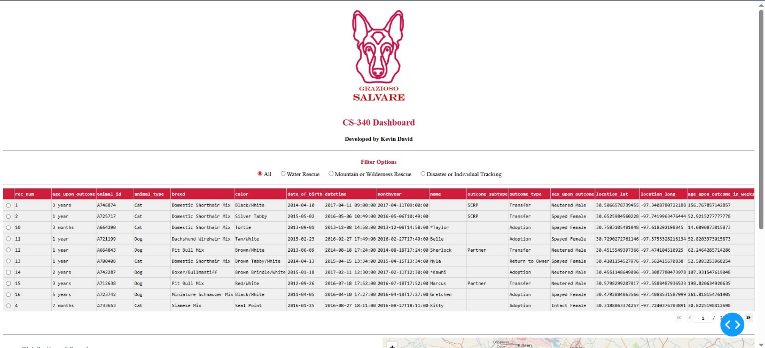
Project 2 Screencast - Grazioso Salvare Dashboard.mp4

